**Connect 4 minimax AI**

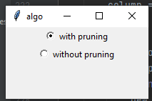AI minimax and minimax with alpha-beta pruning were both applied and the user gets the chance to determine the whether he wants to face a pruning algorithm or not showed in the following picture:

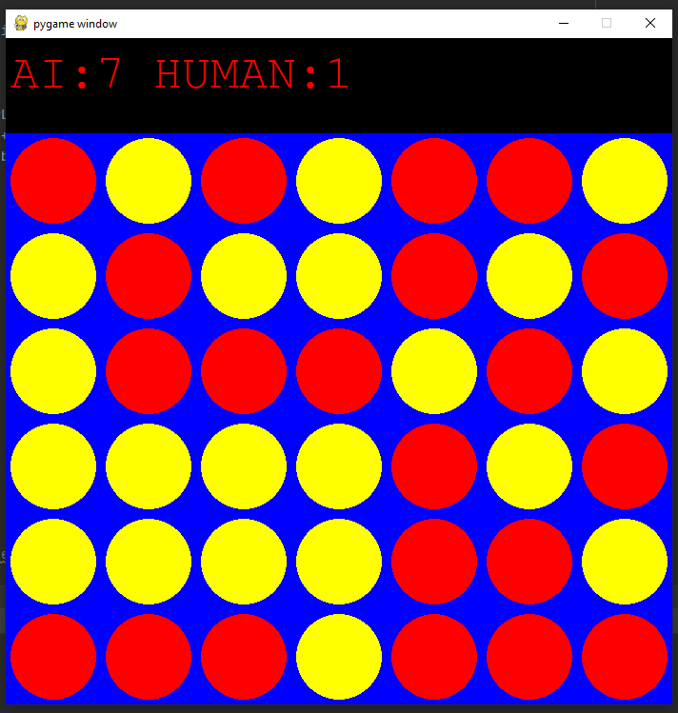after he chooses the algorithm he starts off the game with the AI and it does not end until all slots are full (no more moves available)

with Alpha-Beta pruning invading about 4 nodes of the minimax tree the game takes about 30 seconds.

Without Alpha-Beta pruning with also 4 nodes in the tree the game takes about 50 seconds.

Not a big difference but after trying to explore 5 nodes in the tree there is actually a big difference:

With Alpha-Beta pruning 5 nodes: 50 seconds

Without Alpha-Beta pruning 5 nodes: 2 minutes and 40 seconds

Regarding the heuristic used we defined a variable *score* it increases if the move will grant the AI 2 pieces in a row or 3 in a row and it decreases whether the user will get 2 in a row or 3 in a row. So, the AI get to determine which move will grant it bigger score.

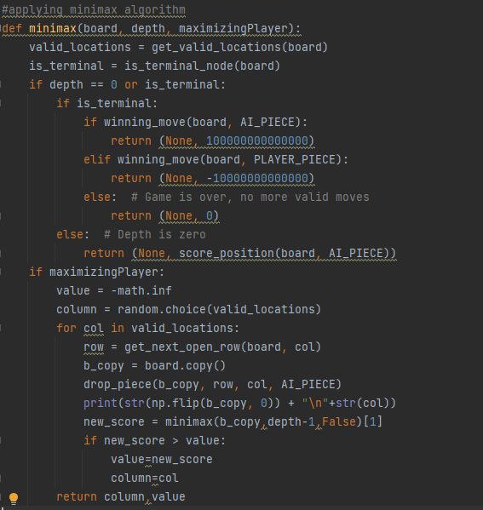Here is the minimax algorithm maximizing player:

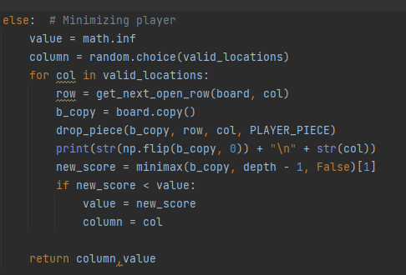Minimizing player:

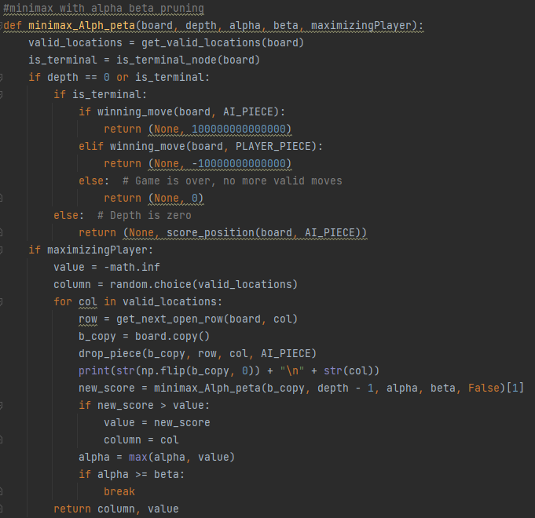Here is the minimax with Alpha-Beta pruning maximizing player:

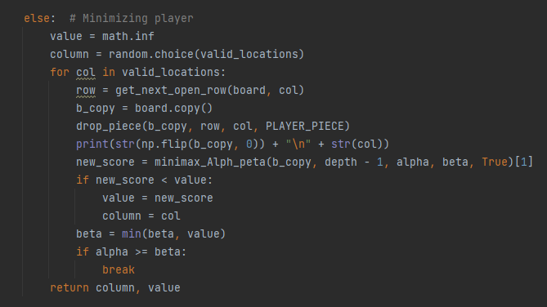Minimizing player for minimax Alpha-Beta pruning:

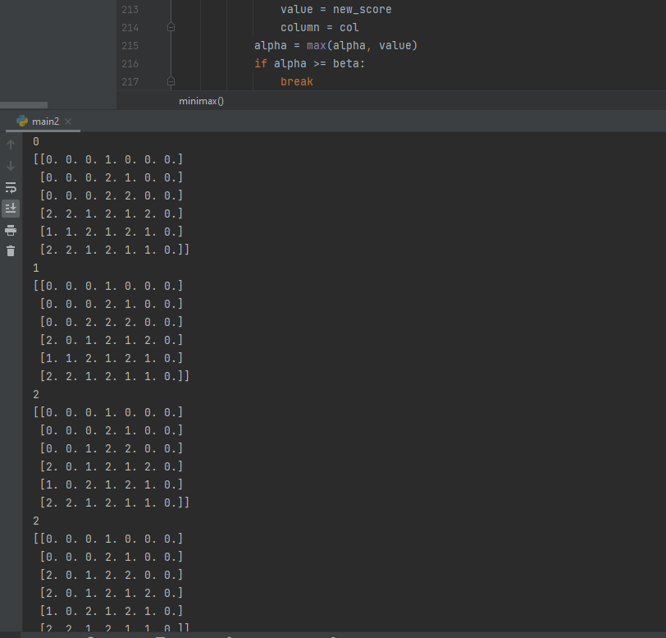The code does show you the progress of the algorithm and all the nodes it explores it prints it below in the screen in case there is an error you want to trace:

Some important notes:

The game is an array that was initialized with zeros which basically means it is all empty.

1 in the array means the player placed his piece in the location

2 in the array means that this is the AI’s piece

Heuristic:

It is basically a score increases and decreases whether the AI is getting closer to winning or the human is getting a winning move.

Each consecutive pieces changes the score with different values for AI and human.

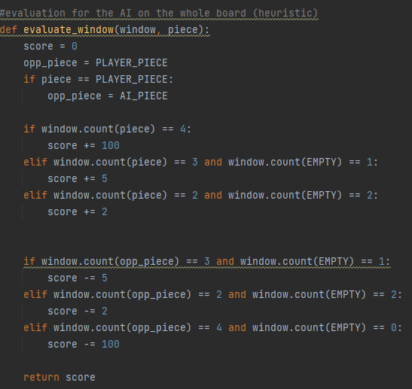Here is the evaluation function for the current window from the AI’s prospective:

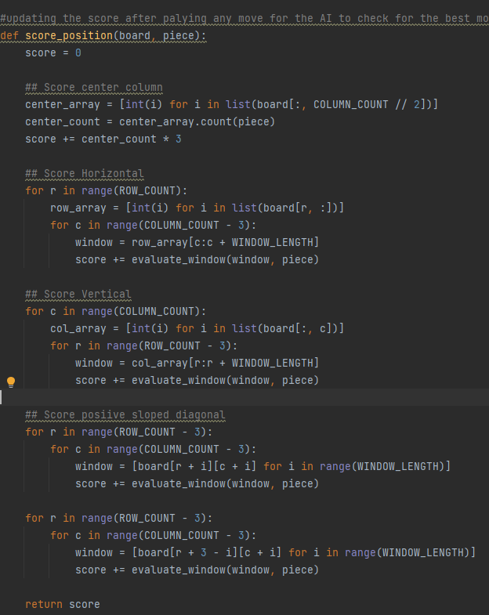This is the function which checks for the upcoming move’s score:

Name: Abdelrahman Gaber ID: 6591

Name: Hazem Sha’ban ID:6328